Table and Areas (Menu Management)

Overview :
The Tables/Areas section in Petpooja allows you to manage table assignments and area configurations for your restaurant. This functionality helps streamline operations by enabling you to set table capacities, assign tables to specific areas, apply discounts, and control reservation statuses. The Menu Management pathway allows restaurant operators to efficiently organize tables and areas, ensuring smooth service flow and better customer experience.

Path : billing.petpooja.com > Menu > Menu & Discount > All In One Menu > Tables/Areas.
outletwise_link : https://menu.petpooja.com/menus/res_tables_list/

Step 1 : Billing.petpooja.com in Steps to reach Tables/Areas : Open your browser and go to billing.petpooja.com.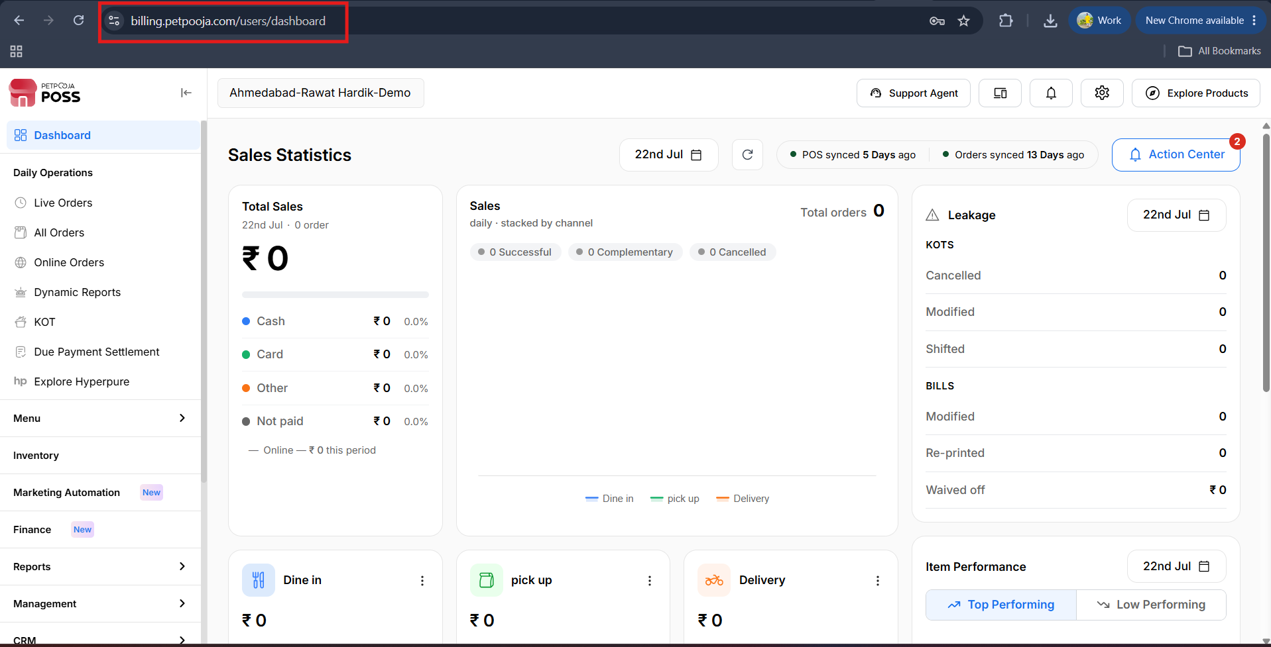
{Image Name: PetPooja Dashboard,
Description: The highlighted URL indicates that this is the billing.petpooja.com. Here is an image of step 1 Billing.petpooja.com in Steps to reach Tables/Areas.}
Step 2 : Menu in Steps to reach Tables/Areas : Click on the Menu section from the dashboard.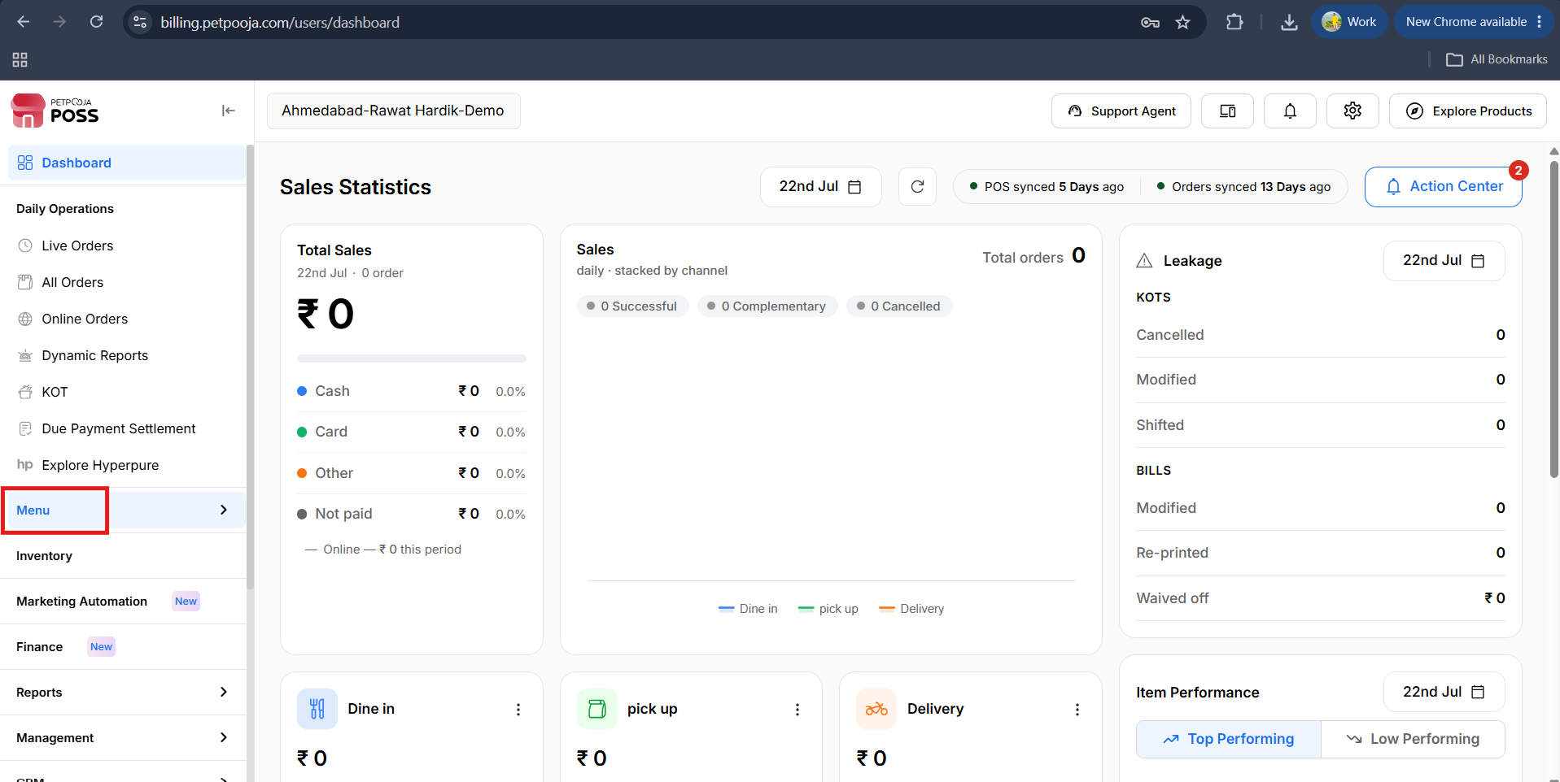
{Image Name: PetPooja Menu,
Description: The highlighted section on the left panel shows the "Menu" option under the navigation bar. This is part of the main dashboard on billing.petpooja.com, guiding users to manage menu items. Here is an image of step 2 Menu in Steps to reach Tables/Areas.}

Step 3 : Menu & Discount in Steps to reach Tables/Areas : Inside the Menu Management section, click on Menu & Discount.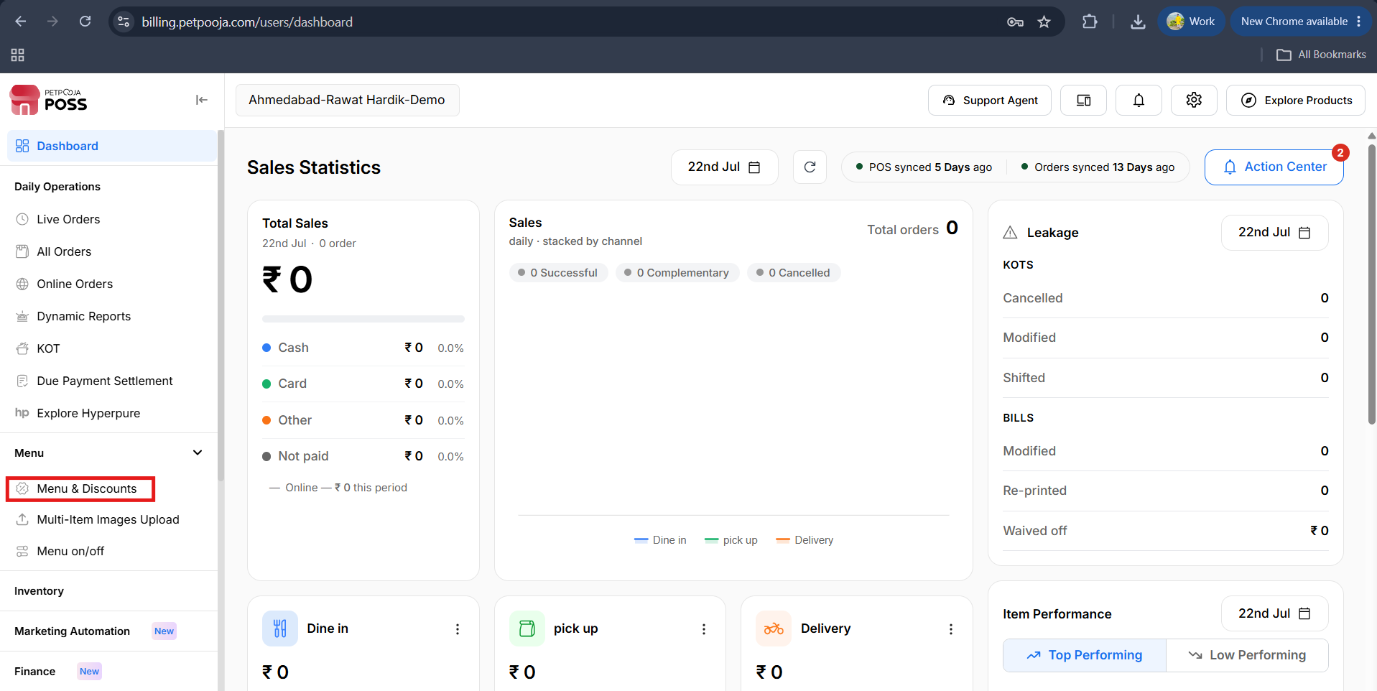
{Image Name: Menu & Discounts Page,
Description: The highlighted section shows the "Menu & Discounts" option selected under the Menu category in the left navigation panel. Here is an image of step 3 Menu & Discounts in Steps to reach Tables/Area.}

Step 4 : All In One Menu in Steps to reach Tables/Area : Inside Menu & Discount, go to All In One Menu, then click on Tables/Area.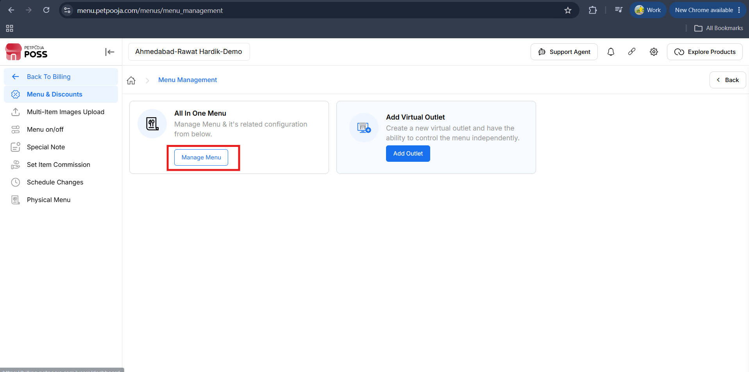
{Image Name: Menu Management - All in One Menu,
Description: The highlighted section shows the "All in One Menu" option, allowing users to manage the menu and its related configurations. This step is accessed from the "Menu & Discounts" section. Here is an image of step 4 All in One Menu in Steps to reach Tables/areas.}

Step 5 :Tables/Areas After The Click On “All In One Menu”. Then Click On The “ Tables/Areas”.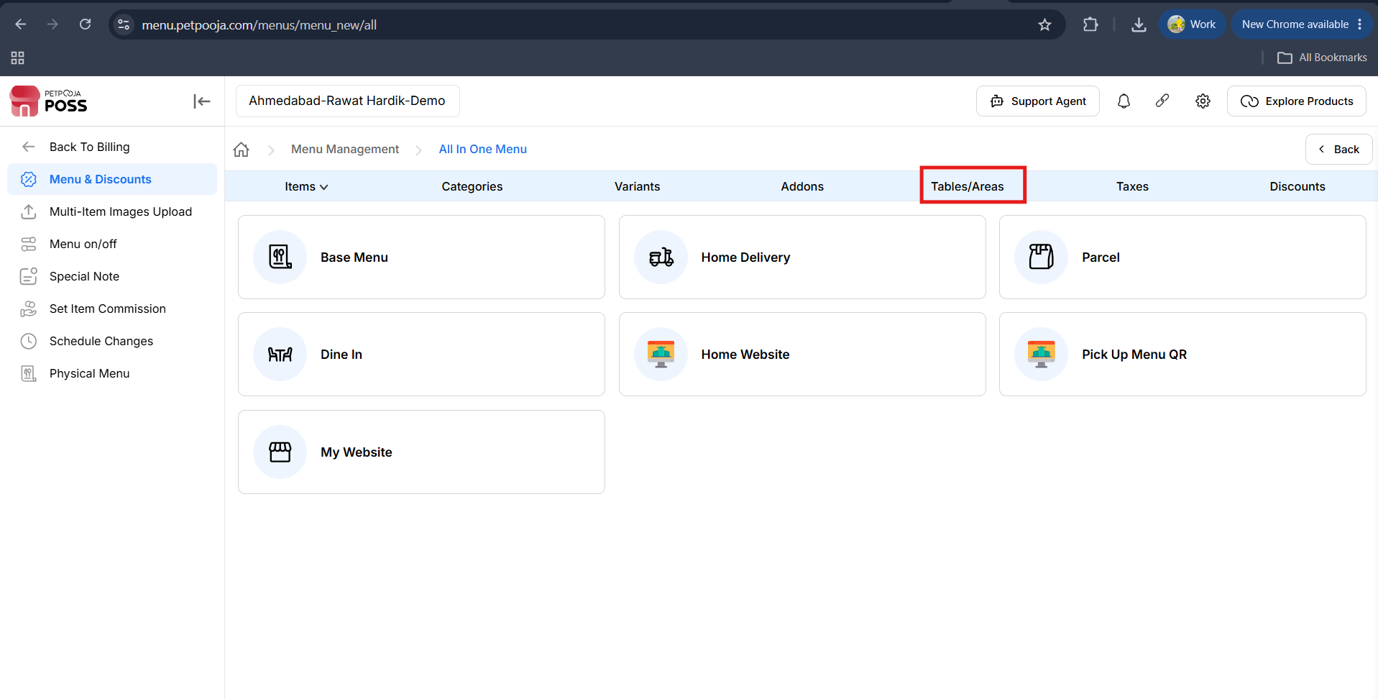
{Image Name: Tables/Areas Tab - Menu Configuration,
Description: The highlighted "Tables/Areas" tab is part of the All in One Menu configuration, allowing users to manage different dining sections such as Dine In and Parcel. Here is an image of step 5 Tables/Areas in Steps to reach Tables/Areas.}

Tables and Areas (Add Menu)
outletwise_link: https://menu.petpooja.com/menus/res_tables_list/

Tables (Tables and Areas) :
outletwise_link: https://menu.petpooja.com/menus/res_tables_list/
Add New Tables (Tables):For adding new tables, click on the "Add New Tables" button.
outletwise_link: https://menu.petpooja.com/menus/res_tables_list/
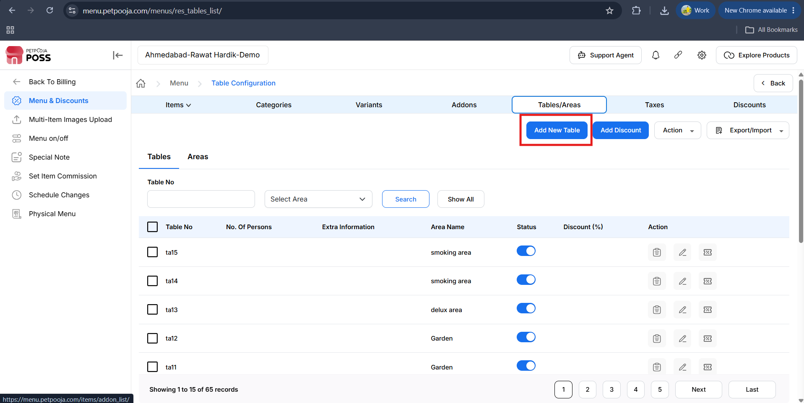
{Image Name: Add New Table,
Description: Here is an image showing the 'Add New Table' button highlighted under the Tables/Areas tab.}
- (Add New Tables) Table No (Mandatory) : Enter the table number or range of tables.You can input multiple table numbers using a comma (,) or define a range using a colon (:).
- (Add New Tables) No. of Persons : Specify the number of persons that each table can accommodate.
- (Add New Tables) Extra Information : Optional notes or comments related to the table (e.g., location, accessibility, preferred use).
- (Add New Tables) Available for Reservation : A checkbox to indicate whether the table is available for reservations.
- (Add New Tables) Save Changes – Saves the new table(s) with the provided information.
- (Add New Tables) Cancel – Discards the changes and returns to the previous screen.
Examples (Table No) :
- A10:A20 – Table range
- AA10:AA20,BB1 – Single and range combination
- A10:A100,B1:B20 – Multiple ranges
- 1,2,3 – Multiple individual tables
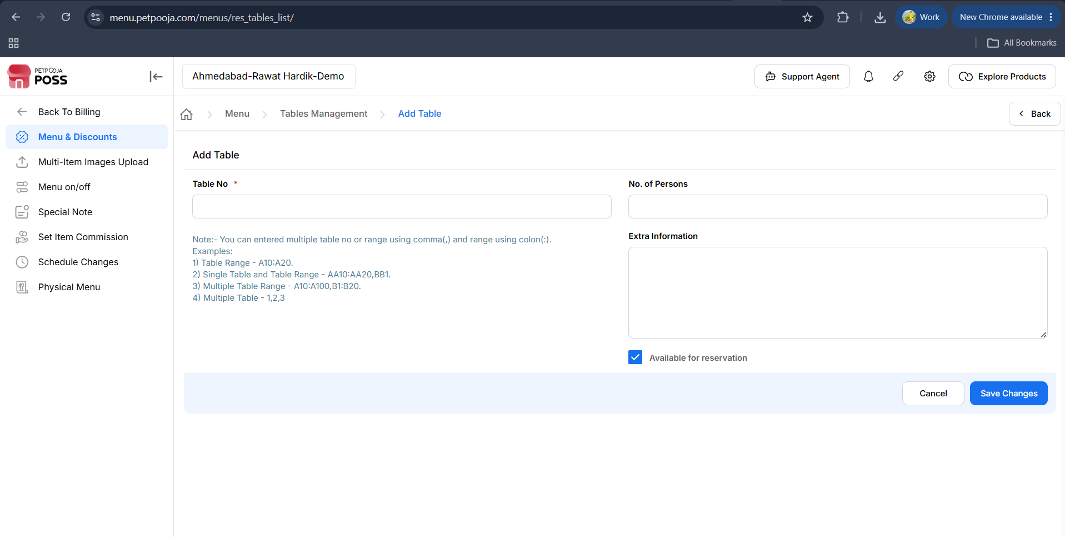
{Image Name: Add Table Screen,
Description: Here is an image showing the Add Table screen where users can enter table number, number of persons, and additional information, along with a reservation option.}
Note (Table and Areas) : If any changes are made In the Table and Areas from the dashboard, manual sync is mandatory in POS/Billing Application.
Add New Discount (Tables): Table-wise Discount Configuration
- To apply a table-wise discount, first select the required table.
- Click on Add Discount, then enter the discount percentage you want to apply for the selected table.
- Click Save to apply and store the discount, or click Cancel to discard the configuration.
Action (Tables):
- Active:
  - First, select the required table(s).
  - Click on the Action button, then choose Active.
  - Confirm the action to Active the selected table(s), or click Cancel to abort the operation.
- Inactive:
  - First, select the required table(s).
  - Click on the Action button, then choose Inactive.
  - Confirm the action to deactivate the selected table(s), or click Cancel to abort the operation.
- Remove:
  - First, select the required table(s).
  - Click on the Action button, then choose Remove.
  - Confirm the action to remove the selected table(s), or click Cancel to abort the operation.
Export/Import Tables (Tables):
Click on the Export / Import button to manage table data.
To export tables, click Download Tables to download the spreadsheet (SS) containing the table details.
To import the updated data, click Choose File, select the updated spreadsheet, and then click Upload to apply the changes.
Note: Update the required fields in the spreadsheet. Note that only No. of Persons and Available for Reservation fields can be modified.
Status (Tables) : To enable or disable tables, you can change their Status accordingly.
outletwise_link : https://menu.petpooja.com/menus/res_tables_list/
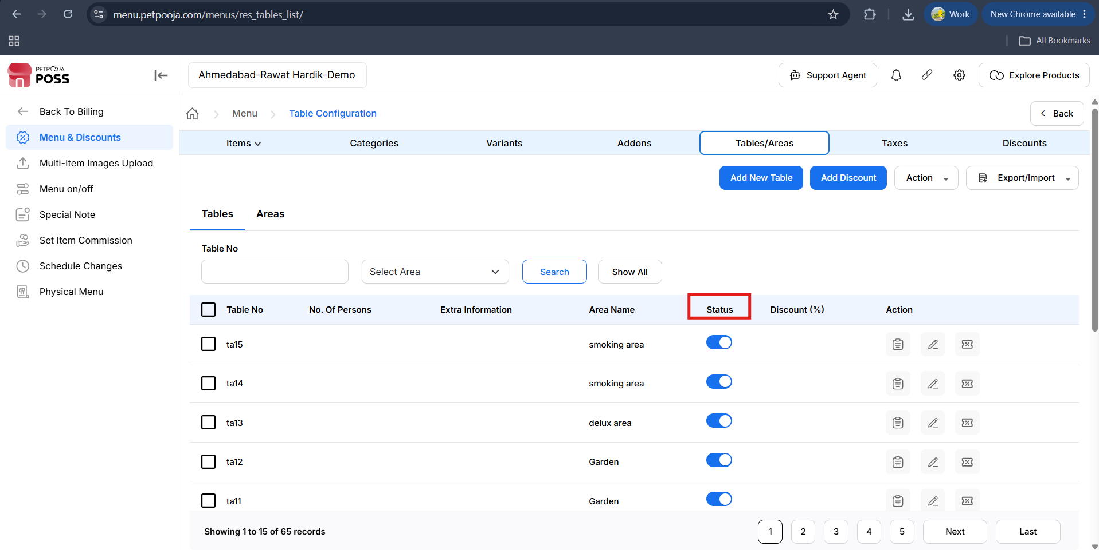
{Image Name: Table Status Toggle,
Description: Here is an image showing the toggle buttons to activate or deactivate the status of tables.}
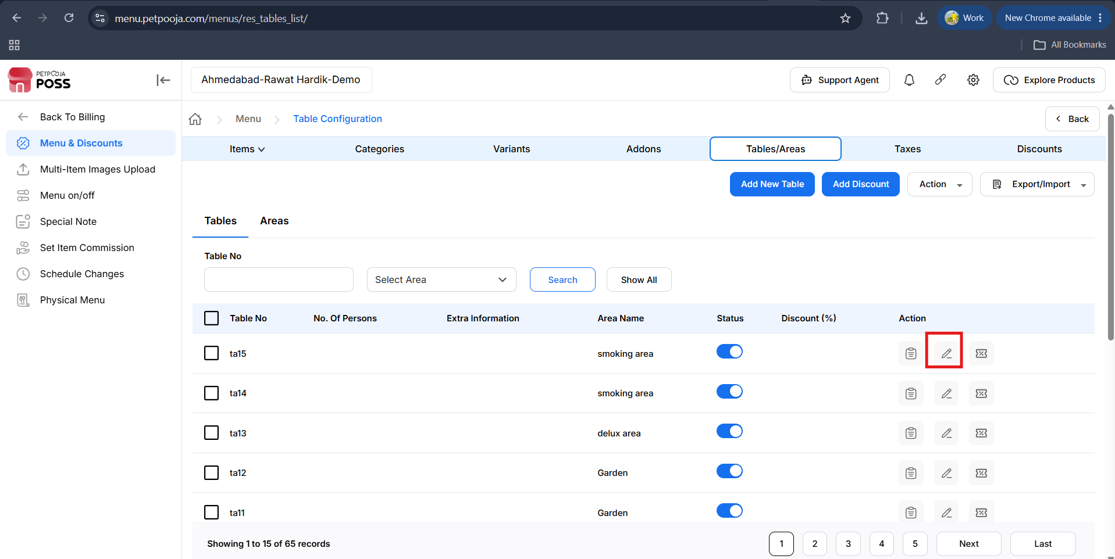
{Image Name: Edit Table Details,
Description: Here is an image showing the edit icon in the Action column to update table details.}

Edit Table (Tables) :In the Petpooja system, you can manage tables and areas through the dashboard for better dine-in organization. To edit an existing table, click the Edit Table option where you can change the number of guests it can seat and mark whether the table should be available for reservation. The table number itself cannot be edited. After making changes, click Update to save or Cancel to discard. Please note that any edits made from the dashboard must be manually synced with the POS/Billing app.For Area Management, click Add Area to configure different dining sections like Indoor, Outdoor, Lounge, etc. You need to assign an Area Name, select the Area Type, and mark it as Active if it's currently in use. You can also assign specific tables to the area using checkboxes or the Check All option to select all. Once setup is complete, click Save Changes. Again, manual sync is required after dashboard updates.Container Charges and Service Charges can be configured for each area. You can choose whether these charges should be applied automatically based on system rules or manually during order processing.

For organizing how areas appear in the system, you can use the Update Area Rank feature. This lets you rearrange the order of areas by assigning each a numerical rank — the lower the number, the higher it appears in the list. You can download the current area list, edit the ranks in a CSV file, and upload it back using the Update Rank button. Only the "Rank/Order" column should be edited; other fields like Area Name or ID should remain unchanged. After any update, manual sync is again required for the POS.
outletwise_link : https://menu.petpooja.com/menus/res_tables_list/
- (Edit Table) Table No – 1 : Displays the table number being edited. This field is not editable on this screen.
- (Edit Table) No. of Persons : Enter the number of guests that the table can accommodate. This field is mandatory for updating the table.
- (Edit Table) Available for Reservation : Checkbox to indicate whether this table can be reserved.
- Checked: Table is open for reservations.
- Unchecked: Table is not available for reservation.
- Cancel : Discards any changes and closes the dialog.
- Update : Saves the modifications made to the table.
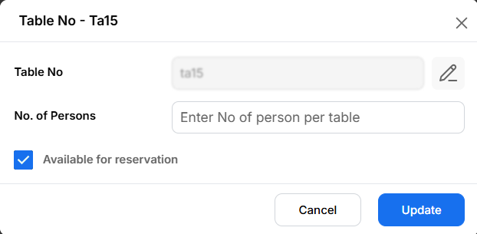
{Image Name: Update Table Information,
Description: Here is an image showing the update popup for editing the number of persons and reservation status for a table.}
From now on, you can edit the table number from here as well.
Note (Edit Table) : If any changes are made In the Edit Table from the dashboard, manual sync is mandatory in POS/Billing Application.

Areas (Tables and Areas) :
outletwise_link: https://menu.petpooja.com/menus/res_areas_list/
Add Area (Areas) : To add a new area, you need to click on Add Area. After clicking on Add Area, you need to fill in the details.
outletwise_link: https://menu.petpooja.com/menus/res_areas_list/
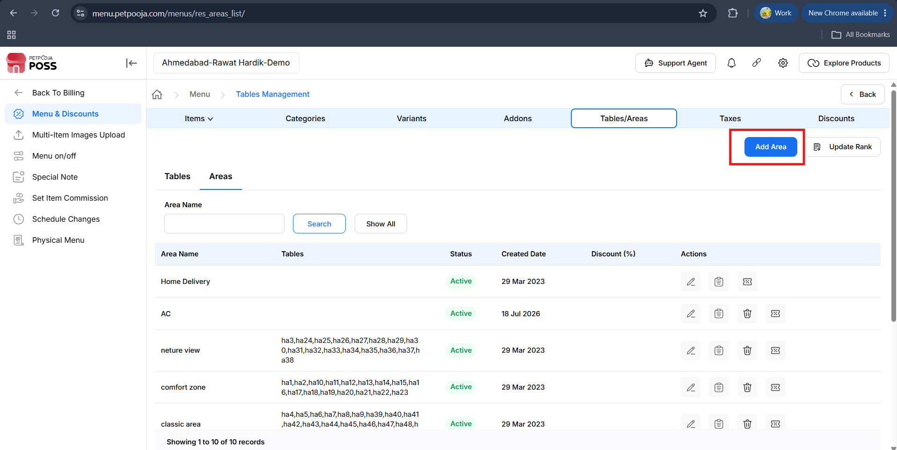
{Image Name: Area Management View,
Description: Here is an image showing the Areas tab under Table Configuration, with options to add new areas and view existing ones.}

Area Details (Add Area) :
outletwise_link: https://menu.petpooja.com/menus/res_areas_list/
- (Area Details) Area Type : Area Typical You can select Indoor, Outdoor, Rooftop, Lounge, VIP, and others.
- (Area Details) Area Name : Enter a name for this specific area, such as "Main Hall" or "Terrace Zone", etc.
- (Area Details) Active : Indicates that the area is currently enabled or not.

Tables Section (Add Area) :
outletwise_link: https://menu.petpooja.com/menus/res_areas_list/
- (Tables Section) Check All : Selects or deselects all available tables in one click.
- (Tables Section)Table Selection : Individual table checkboxes (e.g., A10, A11... A20) allows assigning specific tables to the area.
- (Tables Section) Marks the area as active or inactive in the system.
- (Tables Section) Save Changes :Commits the configuration and updates the system with the area setup.
- (Tables Section) Cancel : Discards any changes made and resets the form.

(Areas) Action :
Edit Area (Action) :

Description: This option allows you to make changes to the billing details within the selected Area Type.

Show Changes (Action) :

Description: After making edits, this option shows the updated details of the bill, letting you see how the changes have affected the overall amount or details. It’s useful for reviewing and verifying the updates before finalizing the bill.

Delete Area (Action) :
- Description: Clicking this option allows you to delete the selected area using the Delete button
- Note: System-generated areas cannot be deleted or removed.
Note (Add Area) : If any changes are made In the Add Area from the dashboard, manual sync is mandatory in POS/Billing Application.

Container Charge And Service Charge (Add Area) :
- Default Configuration of Order Types : The system will automatically calculate and apply the packaging charge for the order, based on the predefined settings.
- Calculate Automatically : The system will automatically calculate and apply the packaging charge for the order, based on the predefined settings.
- Don't Calculate Automatically : Packaging charges will not be calculated automatically. Manual input or configuration will be required during order processing.
Note (Container Charge And Service Charge) : If any changes are made In the Container Charge And Service Charge from the dashboard, manual sync is mandatory in POS/Billing Application.
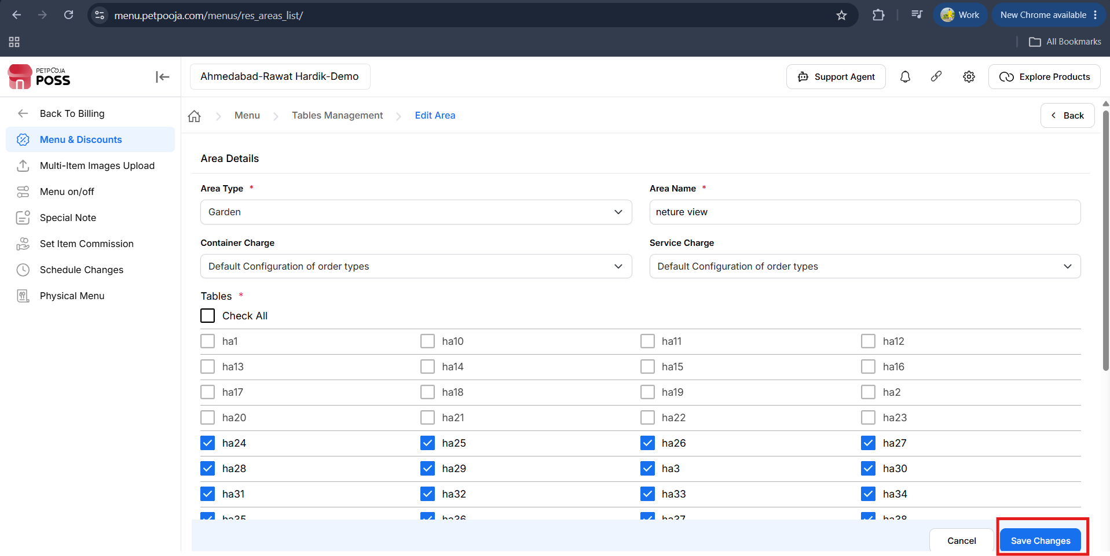
{Image Name: Area Configuration Details,
Description: Here is an image showing the Area Details form used for configuring area type, name, charges, and table assignment.}

Update Area Rank (Tables and Areas) :
outletwise_link: https://menu.petpooja.com/menus/res_areas_list/
The "Update Rank" button in Petpooja is used to change the display order of areas.
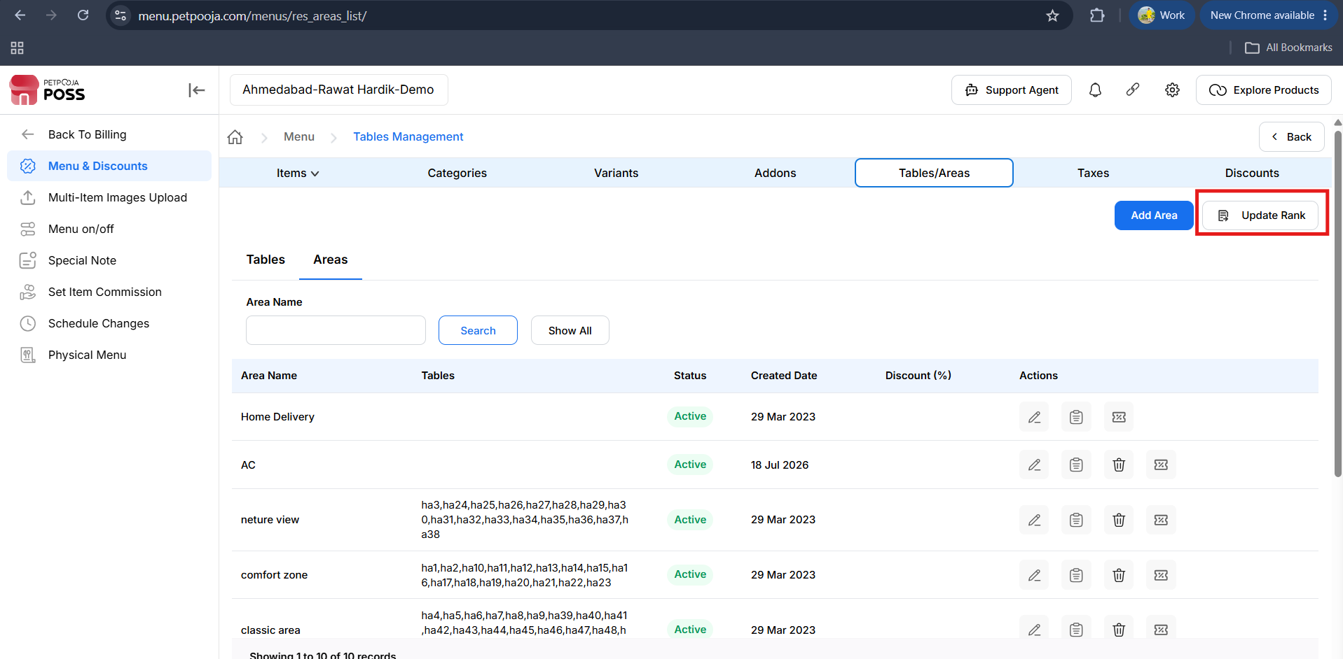
{Image name : "Update Area Rank" ,
Description : Here is an image of showing that update rank Option Where you can update your area rank}

Sheet Column Details (Update Area Rank) :
- Id : The unique system-generated identifier for each area.
- Note: This column should not be modified.
- Area Name : The name of the area (e.g., Ground Floor, Rooftop, Balcony).
- Note: This column is for reference only and should not be changed.
Rank/Order (Update Area Rank) :
outletwise_link: https://menu.petpooja.com/menus/res_areas_list/
- This is the only column that can be modified.
- Enter a numeric value to set the order.
- To show an area at the top, assign it the rank 1.
- Lower numbers appear higher in the list, higher numbers appear lower.
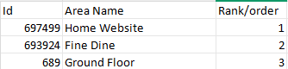
{Image Name: Area Ranking Table,
Description: This image displays a simple table with three columns—Id, Area Name, and Rank/order—listing three area entries: Home Website, Fine Dine, and Ground Floor, with their respective IDs and rank orders.}
Update Rank (Update Area Rank) :
outletwise_link: https://menu.petpooja.com/menus/res_areas_list/
- This button lets you upload a file CSV that contains the new rank/order of the areas.
- The file should list the areas and their desired display order.
- Downloads the current list of areas along with their existing ranks.
- After selecting the updated file with new ranks, click this button to Upload.
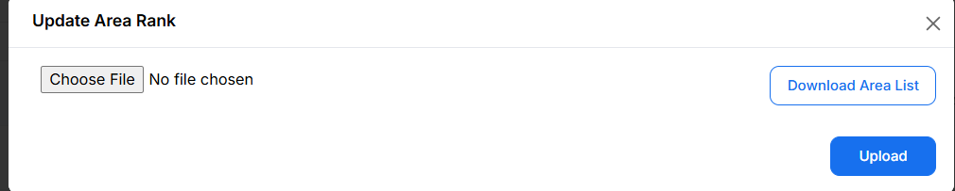
{Image Name: Update Area Rank,
Description: This image shows a pop-up interface for updating the rank of areas. It includes an option to choose a file for upload, a “Download Area List” button, and an “Upload” button to submit the selected file.}
- The table shown in the image is a sample area ranking file used in Petpooja's "Update Area Rank" feature. It is typically uploaded via the "Update Rank" option to rearrange the display order of areas in the POS system.
Note (Update Area Rank) : If any changes are made In the Update Area Rank from the dashboard, manual sync is mandatory in POS/Billing Application.

